|  |
| --- |
| RIFT  Venkatesh Nitin Vayachal |

# Game Summary

RIFT is an adventure, mystery, RPG game with a focus on exploration and mystery solving rather than combat. You will play as two characters – Nathan and Lex. The game alternates between the two characters as the story progresses and the mystery unfolds. You will investigate the death and disappearance of Nathan’s mom that took place 20 years ago and get to the truth.

## Game Design Pillars

1. Exploration – the majority of the gameplay is the player exploring the woods, trying to find clues and get pieces of the story
2. Puzzle Solving – the player will need to piece together the pieces of the puzzle and get the bigger picture to get to the truth
3. Adventure – The player must escape certain dangers in the environment while exploring the small town of Hallowridge, including the lake located near the town, Lake Hallow.

## User Experiences

The players will feel a sense of accomplishment after solving the puzzles. The exploration and adventure will give a sense of urgency to the game, keeping players on their toes. The story and the time-traveling element would appear interesting to the player.

# Core Gameplay

## Aim of the Game

* The core gameplay will be achieved by a series of game mechanics like running, jumping, sliding, rowing a boat, swimming, and puzzle solving.
* The players are trying to unveil the story by gathering clues to a puzzle. The players will gather these clues by exploring and investigating the village and the surrounding area, including the lake.
* The captivating story and investigations are the USP of the game.
* When playing RIFT, the players will feel accomplishment when solving puzzles, fear or anxiety when in a hostile environment like chase sequences, and joy or sorrow when they unveil the complete story.
* The target audience will be from young adults to adults.
* The game takes you through the lives of Nathan and Lex. You get to experience their journey to the truth with them as you progress in the game.

## 

## Game Design Goals

* The primary objective in the game is to get to the truth about Nathan’s mom’s disappearance and death that happened 20 years ago, and find out where Lex’s and Nathan’s stories meet.
* The players should get a sense of accomplishment when solving puzzles and unveiling the mystery. The players will experience anxiety and fear in hostile situations, aided by visual and sound effects. At the end of the game, the players will either feel joy or sorrow when they know the whole truth.
* Key Mechanics –
  + Exploring –
    - Walking, Jogging, Running, and Jumping to Traverse the map
    - Sliding and crouching to escape the dangers
  + Puzzle Solving –
    - Sneak up to listen to eavesdrop on conversations to get clues
    - Gather clues and piece them together to reveal the story and/or the next clue
* Player Engagement –
  + Puzzle Solving – Gathering clues, solving puzzles, and progressing further in the story will keep players engaged
  + Story – The captivating story of Lex and Nathan will help increase player engagement
  + Time Travel – Traveling through time and experiencing a world from ages past will be appealing to players
* The game will have a low-poly 3D art style.
* The time travel element combined with the problem solving and exploration makes the game unique and appealing to the players.
* The game will be playable on PC and Mac and will be free to download on Steam.

# Features

## Game Mechanics

### Movement

1. Walk/Jog/Run – Players will move using the W-A-S-D keys or the left joystick on their controllers. The movement mechanic will allow players to explore the game world, gather clues, and escape hostile environments.
2. Jump/Slide – These actions enable players to navigate obstacles while exploring or escaping hostile environments.

### Puzzle Solving

1. Eavesdropping – Players can eavesdrop on conversations when close to their target to gather important information for their investigations.
2. Collecting Clues – Players will interact with objects in the game world that serve as crucial clues in their investigation.

## Characters

### Nathan

Nathan is one of the characters you’ll play as. The story begins with the disappearance and death of his mother. He still mourns the loss of his mother and yearns for closure. He will stop at nothing to learn the truth about her disappearance. When playing with him, you will share his loss and his undying want for the truth.

### Lex

Lex is the second playable character in the game. She is a young girl living with her mother, stepfather, and stepsister. After being blamed for the disappearance of her stepsister, she sets out to find the truth and prove her innocence.

## Environments

### The Town of Hallowridge

This is a small town by a lake where people live happily. However, unusual activities have been reported lately, like the appearance of animal species that haven’t been seen there for 20 years. As a result, this town has an unsettling atmosphere.

### Lake Hallow

This man-made lake is filled with cypress trees adapted to the still-water ecosystem. Various dangers exist in and around the lake, including crocodiles, poachers, and mysterious animals that appear out of nowhere. Because it is misty and creepy at night, you want to stay away from this lake during the dark hours.

## User Interface

The game's user interface will be minimal. With only the necessary information displayed on the scene at any given time, players will have the most immersive experience.

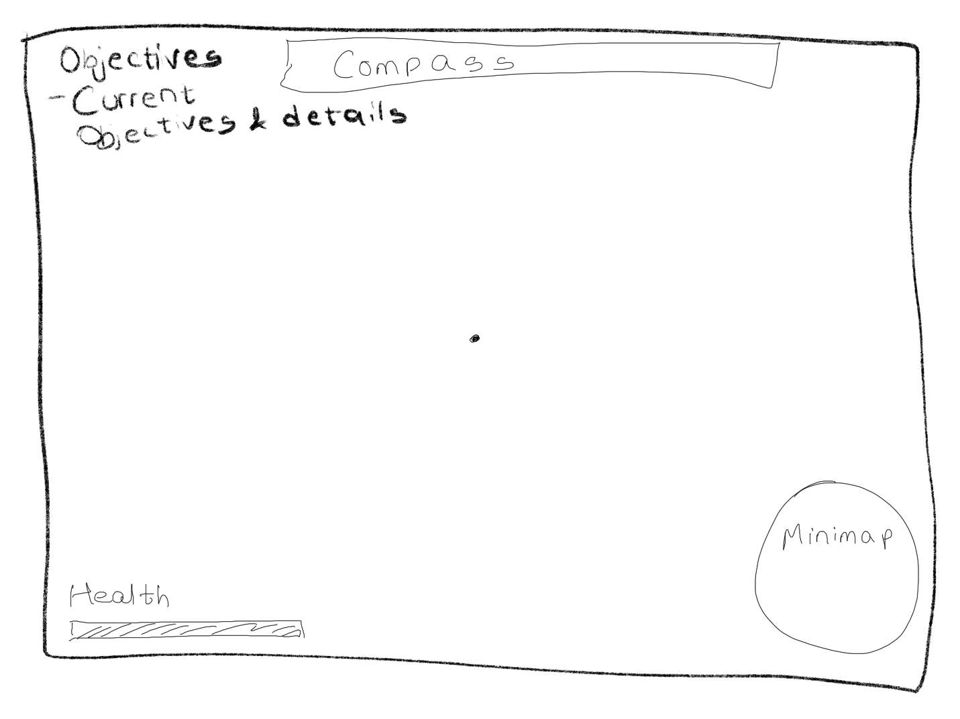

## Unique Features

The game features unique elements such as time travel and puzzle-solving, making it a distinct player experience. Unlike most other games on the market, it switches between two characters.

## Perspective

The game will feature a third-person camera perspective, allowing players to focus on and enjoy the game world around them. When interacting with features like time travel through the rift, players will feel excited about discovering and exploring a new world to find potential clues.

# 

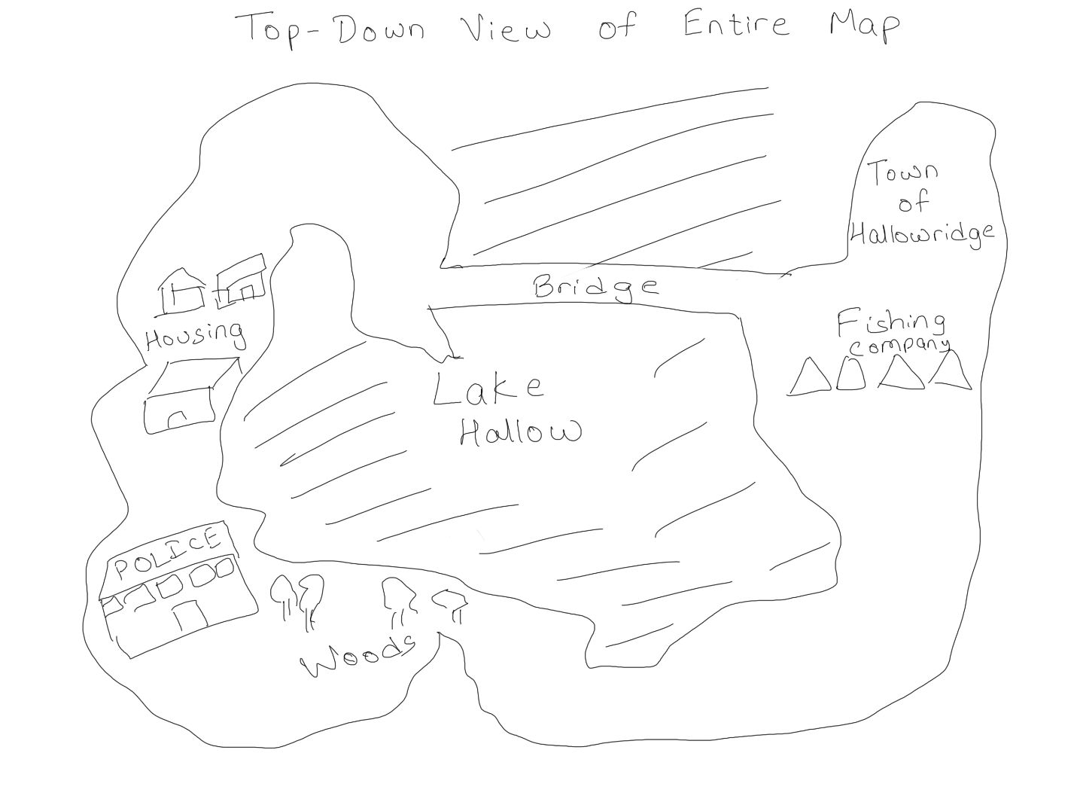

# Player Mechanics

## Core Mechanics

### Movement (Walk, Jog, Run, Jump, Slide)

1. Walk
   1. Keyboard: W forward, A move left, S move backwards, D move right
   2. Controller: Left Joystick Up to move forward, Left Joystick Left to move left, Left Joystick Right to move right, Left Joystick Down to move backwards
2. Jog
   1. Only possible when using a controller
   2. Same directions as Walk and press Left Stick to toggle on/off
3. Run
   1. Keyboard: Press left shift when moving
   2. Controller: Press left joystick twice to toggle on/off
4. Jump
   1. Keyboard: Space Bar
   2. Controller: A on Xbox key scheme, X for playstation key scheme.
5. Slide
   1. Keyboard: Press LCtrl when running
   2. Controller: Press Right Joystick when jogging/running

### Interaction

1. Players will have the ability to interact with in-game objects. Some of these objects will provide vital information to aid the players’ investigations, while others will reveal information depending on the context. Eg, interacting with a sign that shows a spot will trigger a memory the player had in the past in that location
2. Players will interact with the evidence board, which is accessible from the game’s main menu screen. This board allows players to monitor their progress in the game and the current part of the story.

### Feedback

1. Haptic: All game actions will trigger a haptic (hardware permitting) or other mechanical feedback (vibration on controllers) to enhance player engagement.
2. Audio:
   1. Background Music: The game features a diverse range of tracks for background music. The tracks will align with the game's situation to enhance the player's experience. Eg: Fast-paced music for chases, escaping, a low, eerie, horror music when exploring the lake at night, etc.
   2. Sound Effects: All player actions will have a corresponding sound effect that plays in the game.

# Accessibility

The game features a story narration mode for the visually impaired, as well as an autoplay mode for players with disabilities, which allows them to watch the game being played automatically, enabling them to enjoy the game's progression still.

## 

# Game World

## Overview

The game world consists mainly of two areas: the Town of Hallowridge and Lake Hallow. The feel or theme for the world will be horror-like, with a focus on mysterious elements rather than the supernatural aspect of horror. The background music will add to this effect. With low-pitched and subtly scary music playing in the background, the sound effects and game world elements will support this theme. The lake will follow a similar theme with added effects like fog.

## Key Locations

### The Town of Hallowridge

Hallowridge is a typical small American town where people work hard and make an honest living. However, the town seems to have a mysterious aura. No one can really place a finger on it, but there’s this innate feeling of “something is brewing.” The ghostly appearance of animal species that were thought to be long gone from the area and the mysterious disappearance leading to immeasurable suffering seem to be the theme of this town, even though, for whatever reason, people don’t seem to talk about it all. Maybe they believe it is not real if they don’t talk about it? The game world in the town will be a regular town during the day, and spooky or scary elements will be added at night to emphasize the theme.

### Lake Hallow

This man-made lake has been by this town for over 20 years. It has boosted the economy of the small town of Hallowridge by enabling faster commutes and activities like fishing. People of Hallowridge mainly use this lake as a means of commuting. Almost every house in the town owns a boat. At night, few will dare to wander about, though as many mysterious phenomena have been reported multiple times in the vicinity of the lake. At night, the lake hides under a thick veil of fog that adds to the eerie feeling. The game world around the lake will have a spooky feel that keeps players on their toes.

## History

About twenty years ago, the first settlers of this town decided to make a man-made lake to boost commerce and make their lives better and easier. During that time, a lot of settlers were attracted to this booming town. One of the settlers was Nathan’s mother. Her family’s lives were devastated by her sudden disappearance when she had an accident on the bridge that connected two areas of the town across the lake. Twenty years later, the town is doing well, there are not many new settlers. Nathan still lives in the town and has always been determined to find the truth about his mother. He will not stop at anything to get to the truth.

## Visual Style

The game’s visual style will be mild-toned, avoiding bright and vibrant colors. The art assets would be low-poly 3D assets. The game will have a regular, subtle, medium-paced background music during the day and horror-like or spooky background music at night.

## Environmental Interactions

The game will feature day-night cycles that in-game events trigger. Players will be able to interact with in-game objects like clues and collectibles.

# Characters

## Nathan

### Overview

Nathan is a human male character who is determined to find the truth about his mom's disappearance, which took place about 20 years ago. This obsession has started to take a toll on his present relationships and day-to-day life. He needs to find answers if he has to put this behind him.

### Visual Description

Nathan is of a medium build, six feet tall, and a white American man who prefers to dress casually. He wears jeans and a t-shirt, sometimes paired with a flannel.

## Lex

### Overview

Lex is a human female character. At 13 years old, she is a brave young girl who never shies away from a challenge. She lives with her mother, half-sister, and stepfather. Her strained relationship with her mother often leads to disagreements. When she is blamed for her six-year-old half-sister’s disappearance, she takes it upon herself to find out exactly what happened to her.

### Visual Description

Lex prefers to dress in her jeans and her favorite hoodie, which her dad gave her.

## Relationship

Lex and Nathan know of each other but are not well acquainted. They have seldom crossed paths till now.

## Voiceover and Dialogue

The game features a text-based dialogue system. The game does not have a voiceover.

# Levels

## Overview

The game doesn’t have a traditional multi-level design. Technically, it has two levels—one for the present timeline and the other for 20 years ago. Throughout the game, the players will switch between these levels as the story progresses. As far as progression is concerned, the game does not follow a multi-level progression design.

## Description

The primary and only level of the game features two main elements of the map—the town of Hallowridge and Lake Hallow. The main level features a town with a settlement where multiple families live harmoniously. The town will depict through its setting that it’s a major fishing town.

## Progression

The players will explore the two locations and find clues to solve the mystery. They can explore the town and the lake during the day and at night. The game will take the players through the rift, taking them to a different timeline. The other timeline(level) replicates the main level with modified aesthetics to match the old world.

## Environmental Design

During the day, the environment will feature a typical town setting with houses, people, boats, fishermen, etc. At night, the lake will have a thick fog cover over it. The color palette is neutral for both locations at both times.

## Mechanics

Both levels will feature puzzle solving and exploration.

## Challenges

The game will include challenges such as escaping the search party, finding the clues to solve the mystery, and navigating treacherous terrain.

## Collectibles

The players will find and piece together clues that will help them solve the mystery. The players will also be able to collect tokens found at specific places that trigger past memories.

## Map



# User Interface

## Overview

The game will feature a simple, minimalistic UI that shows the current objectives, player health, and hints wherever applicable. For collectibles, some pop-ups indicate the key to be pressed to collect the item. Action prompts will be displayed during a tutorial or whenever the action is first performed. The game features a pause menu screen that lets players access game settings, quit or pause the game, or access the evidence board.

## Elements

1. HUD—The HUD will hold all the in-game UI elements, such as health, current objectives, hints, prompts, etc.
2. Dialogue Box—The dialogue box communicates with the player and displays the instructions and in-game dialogues.
3. Pause Menu Screen – The pause menu screen has buttons like save game, inventory, evidence board, and settings that enable the player to interact better with the game.

## Functionality

1. HUD –

* 1. Displayed on the screen when the player is in-game
  2. Shows valuable information like current objective, health, prompts like interact or collect, and a mini map

1. Dialogue Box –
   1. Shows dialogue in the form of text
   2. Acts as a way of communication with the player
   3. Displays the thoughts and actual dialogues that the in-game character has as text
2. Pause Menu Screen –

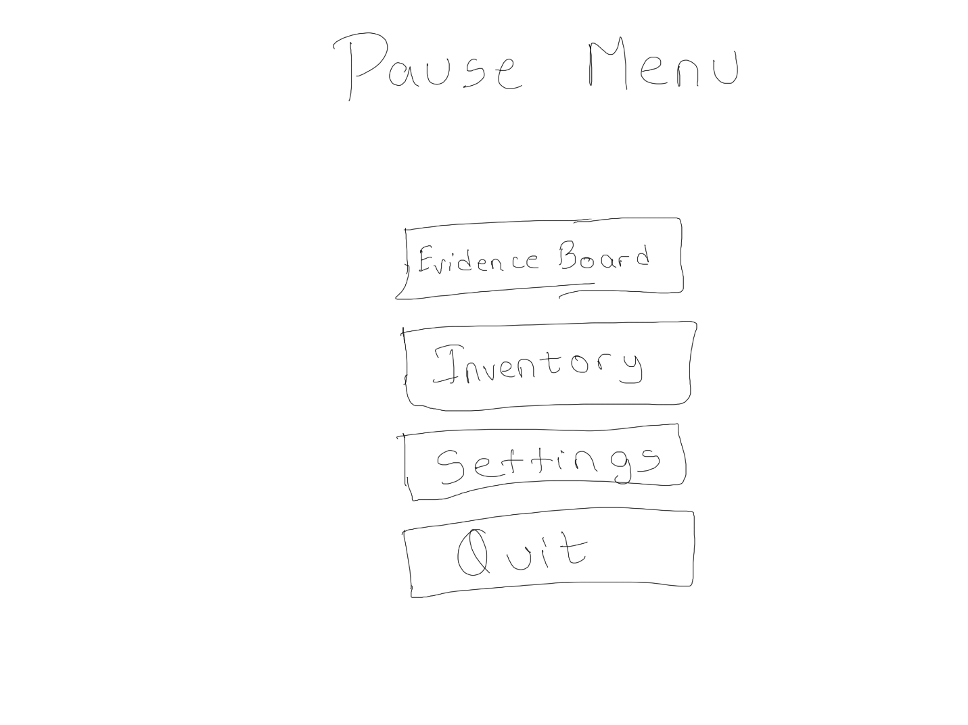

* 1. Holds buttons like inventory, evidence board, save game, settings, and quit game
  2. Inventory –

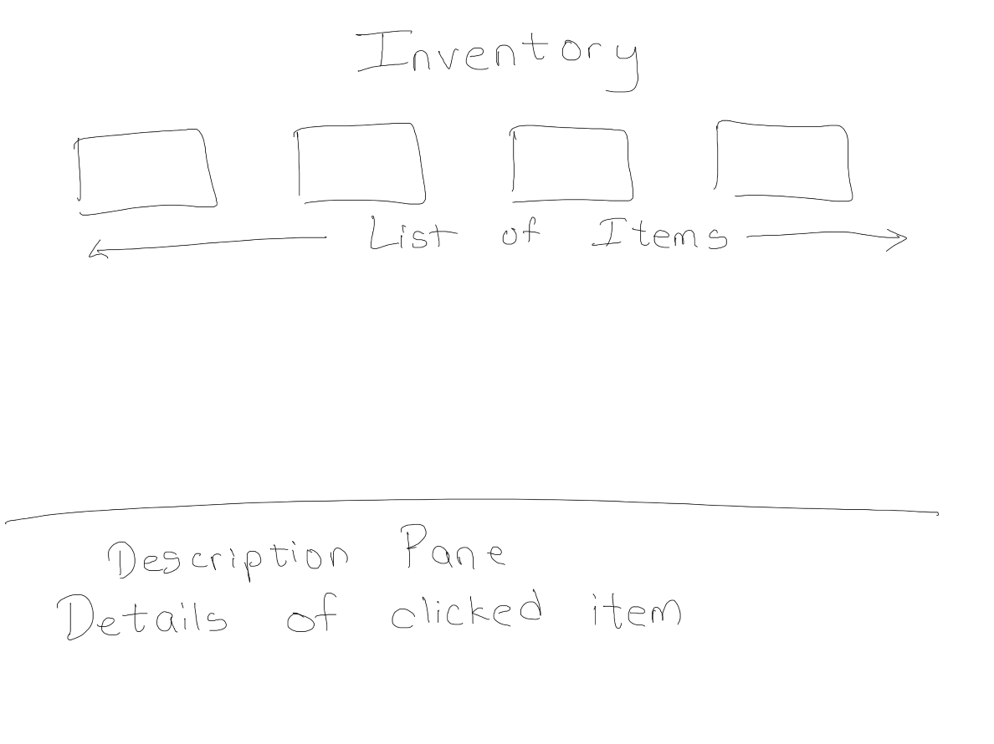

* + 1. A screen that displays all the collectibles that are not evidence
    2. Player can click on the collectible to get more information about it
  1. Evidence Board –

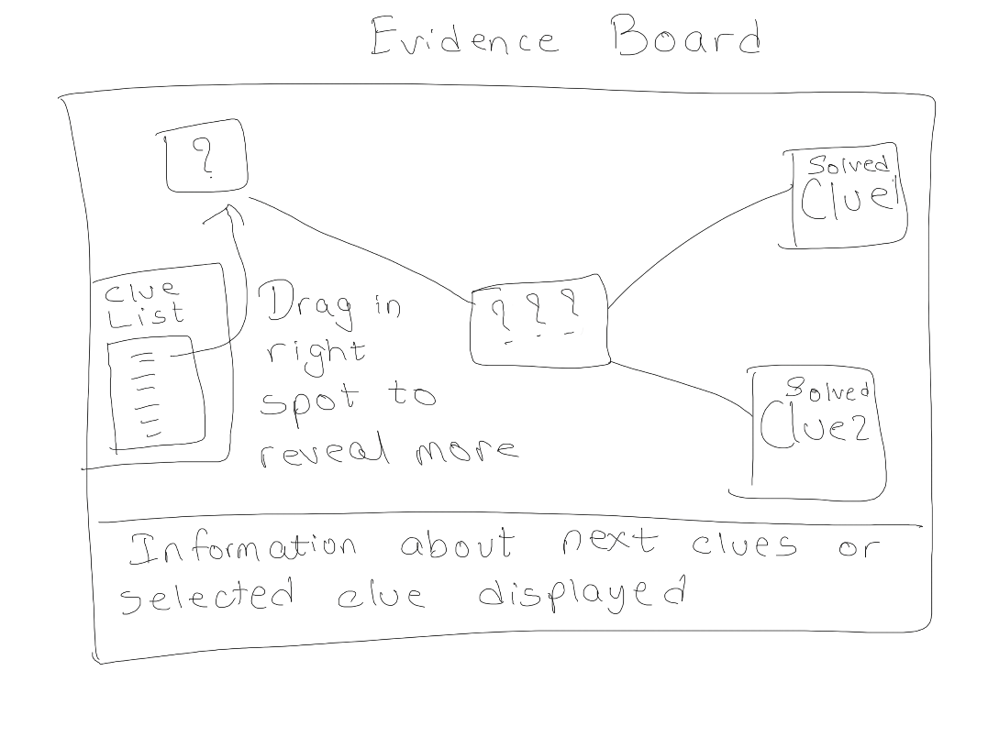

* + 1. All the clues collected by the player will be displayed in the evidence board
    2. The player can click on the clues to get more information about them
    3. The player will need to drag the clues to their proper place on the evidence board to solve the puzzle and get directions to the next clue

## User Flow

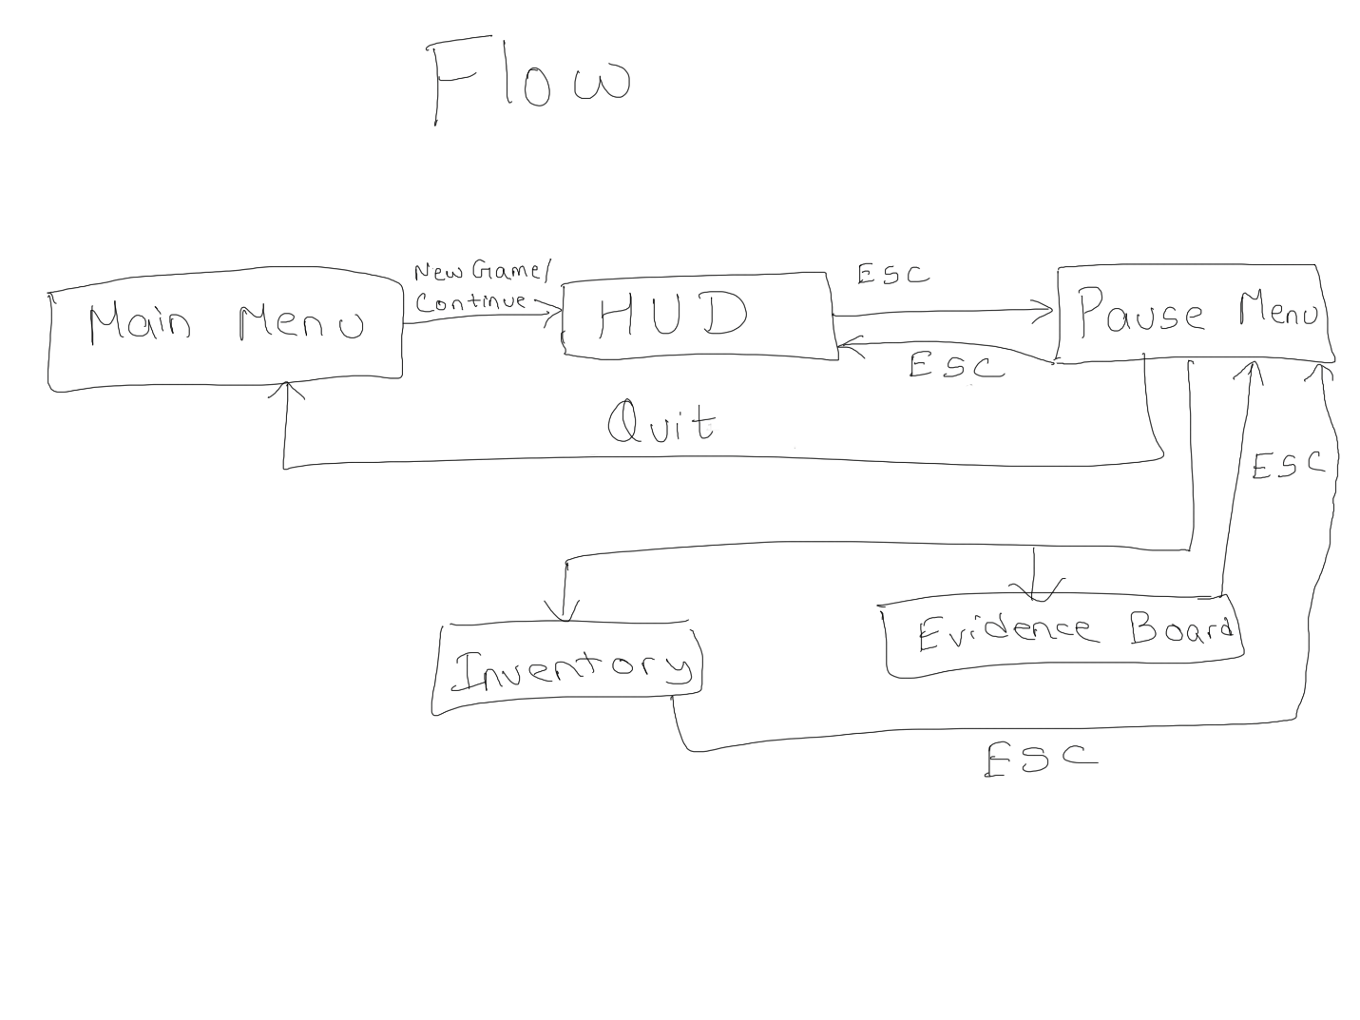

## Interactive Elements

All the interactive buttons will activate only when clicked.

## Consistency

The HUD, pause menu screen, evidence board, and inventory stay consistent throughout the game. This will help in user satisfaction and enhance user experience.

## Feedback and Testing

The UI elements can be modified in function or appearance through constant user feedback and testing.

# Player Experience

## Overview

The game aims to make players empathize with Nathan’s loss and his urge to find the truth about his mother’s disappearance. It also aims to make players empathize with Lex and her troubles. The main feelings the game will bring out are anxiety, accomplishment, joy, and sorrow.

## Emotional Journey

At the start of the game, players will feel sad as they learn about Nathan’s loss and Lex’s broken family. As the game progresses and players find clues and solve puzzles, they will feel accomplished. While exploring the spooky lake at night, players will feel anxious. Players might be conflicted between joy and sorrow when solving the truth and learning the story.

## Player Engagement

The mysterious elements of the story will keep players on their toes. The puzzles and exploration will keep the players wanting to play the game. The element of time travel adds to the excitement of the players and enhances player engagement.

## Interactive Experience

Players will have the option to play with a mouse, keyboard, or controller. They will use the device of their choice to interact with the game world. When using a controller, players will experience enhanced feedback using vibration or haptics.

## Sensory Experience

The background music, the sound effects conveying the feeling and emotion of the current point of the story in the game, and the haptics/vibrations giving physical feedback to the players enhance the sensory experience of the players.

## Memorable Moments

For players, the memorable moments will be when they solve the puzzles and are one step closer to unveiling the truth. The most memorable moment will be at the end of the game when the complete story unfolds.

## Accessibility

The game includes a diverse population by adding features like auto-play and on-screen narration.